Conservation propagation – a legacy project
Rosie Kressman, Horticultural Technician
As the Garden finally begins to wind down after another busy growing year and an abnormally mild November to date, it feels like a good time to reflect on our work as part of the Cotoneaster cambricus conservation partnership and bring you an update from the article I wrote on the same subject for the Newsletter way back in September 2019.
To recap for those of you who may be unfamiliar with this plant, Cotoneaster cambricus is the UK’s sole native Cotoneaster which has its only native habitat on the Great Orme in Conwy, just 20 miles along the coast from here, where its population currently stands at around 80 individuals - most of which were propagated over the last 40 years from a decimated population of six original plants. It is still classified by the IUCN as Critically Endangered, and faces a number of obstacles to its future survival. (IUCN, 2021).
Since 2017, I’ve been trying to propagate this plant from seed and discovered obstacle number one. It just doesn’t want to germinate. With germination rates across all sample groups averaging less than 4% within the first 12 months of sowing it really doesn’t exhibit anything like the profligacy of most of its fellow cotoneaster species. We have found that it can take several years to germinate (despite my best efforts with a nail file, and numerous attempts involving refrigeration, and even feeding the ripe berries to captive pigeons then harvesting the poo), but even taking a smattering of late arrivals into account, this is not a plant that demonstrates any commitment to procreation. I have had some success with taking cuttings, and now our total propagated at Treborth Botanic Garden since 2017 is 19 juvenile plants, (10 of which were from seed, nine from cuttings), and 62 seedlings at various stages of growth.
Obstacles numbers two, three and four are a combination of factors relating to the management of its native environment. Many of the propagated C. cambricus introduced onto the Orme over the last 40 years have been grazed by goats and rabbits into a bonsai population producing few flowers and very little fruit. With such a low rate of germination they have no chance of recruiting naturally in situ in this condition, and it’s unlikely that any miraculously occurring seedlings would survive predation anyway. Further genetic investigation is needed now to establish the variation among the entire population on the Great Orme, and allow propagators to undertake controlled pollination between targeted individuals to maximise genetic diversity. This is important as the current population all arose as propagations from just the six remaining plants, which could be a contributing factor in its lack of viability.
Natalie and I visited the Great Orme with our intern Pete Oswald on one wet day in September this year to meet with other members of the partnership to prospect for sites for reintroduction of some of our juvenile plants, and saw at first hand the third factor limiting opportunities for this plant - a range of invasive species which occupy its native habitat. Arbutus (Strawberry Tree) marching up the slopes from Haulfre Gardens; vigorous gorse, non-native cotoneaster species and Clematis vitalba make a formidable army and would rapidly suffocate any introductions. Natural Resources Wales and the Wildlife Trust are developing a Heritage Lottery Fund project to tackle invasive non-native cotoneaster in North Wales which could extend to the Great Orme, so action may soon be taken to halt its spread. However, as Great Orme Country Park Assistant Warden Sion Dafis explained, the affected sites are also home to a range of extremely sensitive and important plant species which must be taken into consideration in any works done to manage invasives. There is a very delicate balance to be found between supporting one species without inadvertently knackering others - this is not a site for the indiscriminate wielding of glyphosate and mattocks, and unfortunately, to make matters worse, the staffing on the Great Orme is almost non-existent, having been hard-pruned by government cuts and being at the mercy of short-term project funding policies which may fail to provide effective, adequate and continuous long-term protection for the site.
Legacy is a consideration in species conservation. Good work done over decades can be lost in moments, for a number of reasons, some of which I have described above. The inescapable limitation of our human lifespan was brought to the front of our minds in January 2020 as we oversaw the transplanting of what is affectionately – and accurately – known as The Biggest Cotoneaster cambricus In The World. This plant was grown in the 1980s by Morris Morris - the original conservation propagator of C. cambricus - and had thrived in the garden of local resident, historian and conservation propagator Twm Parry, just a few hundred metres from the National Nature Reserve. Twm was very frank in expressing his concern that in the event of his and his wife’s deaths, this plant would have no protection and could well be removed by the next occupants of their house (it’s not the most decorative of plants by most people’s standards!) With this in mind, Twm and Eve have had the foresight to arrange for their superb specimen to be relocated to a fenced-off area on the NNR, where it has settled in well - safe from the attentions of the infamous local fauna - and they are still able to visit their plant in its new home. I think that Natalie agrees with me that following this plant along the road as it dangled inelegantly in a builder’s bag on the bucket of a tractor is one of the most surreal things we’ve ever done in work time!
Amongst all this complexity, I’ll leave you with some positive news. In September, myself and volunteer Will Usher Smith planted out three of our home-grown juvenile plants on the Rock Garden here at TBG. Because of the many challenges yet to be overcome in its native habitat, we are focusing on bulking up our ex situ collection to ensure availability of material for continued conservation efforts well into the future. We inherited responsibility for our two large mature specimens from Nigel Brown when he retired in 2015, and we hope that in many years to come the next Curator, Horticulturists and Volunteers will continue our efforts, with this and other species that we propagate for conservation at Treborth Botanic Garden. This is of course a key role of Botanic Gardens all over the world, which has great environmental, economic and cultural value – perhaps now more than ever, in a rapidly changing and unpredictable climate.

Reference
- iucnredlist.org (2021). Great Orme Berry. [online] Available at: https://www.iucnredlist.org/species/102827479/102827485 [Accessed 3rd December 2021].

Photos author’s own
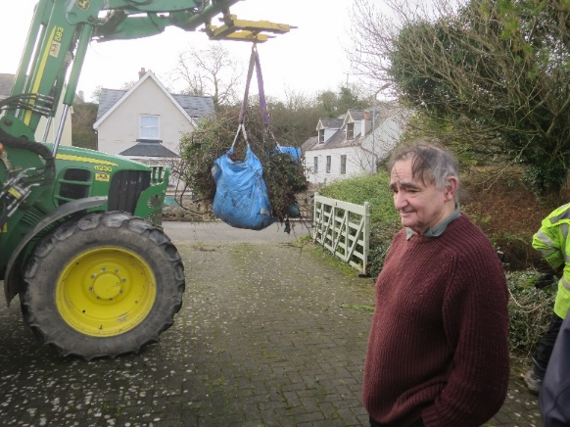
Twm Parry watches as his Cotoneaster cambricus takes to the sky

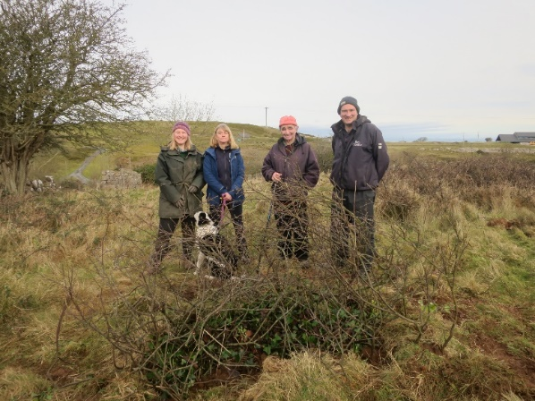
Natalie Chivers (TBG), Sally Pidcock (Great Orme Country Park Warden),
Twm Parry (local resident and historian), Sion Davis (Great Orme Country Park Assistant Warden) with the
newly transplanted Biggest Cotoneaster cambricus in the World

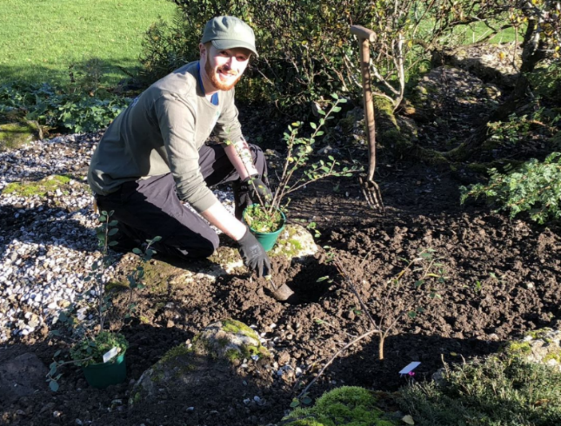
Volunteer Will Usher Smith planting three of our home-grown Cotoneaster cambricus on the Rock Garden

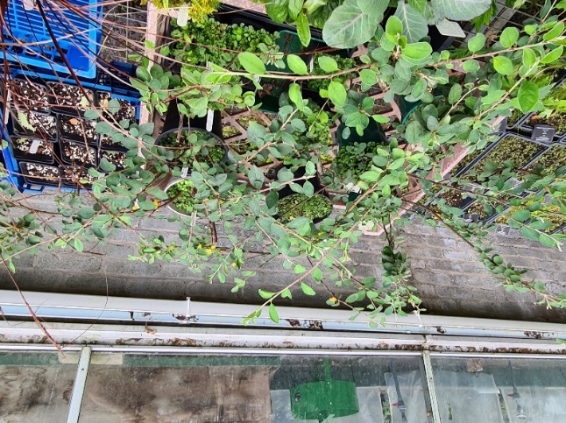
Looking good: some of our juvenile specimens on the prop bench

